Bus Terminal Ridership Forecasting, Analytics, and Data Warehouse Development

Course: Database Project 6430

Date: 1st Dec 2025

Student Name : Sujeeth Parikipandla

Student ID : 00959874

Role : Predictive Factors & Carrier Level Forecasting

Key Predictive Factors
To determine the most important factors that drive passenger volume at the bus terminal, we analyzed the cleaned dataset using a supervised machine-learning approach. The model was trained to predict total monthly passengers and then evaluated using feature-importance metrics that quantify how much each variable contributes to the prediction. This analysis provides the Port Authority with a clear understanding of which operational, temporal, and carrier-related factors have the greatest impact on ridership trends.
The results show that time-based factors are the strongest predictors of passenger activity. Specifically, month, day of week, and season consistently ranked at the top of the importance list, reflecting strong recurring patterns in commuter behavior, holidays, weather cycles, and tourism peaks. Passenger volumes tend to rise sharply during summer months and major travel periods, while winter months typically show lower demand, making these temporal variables essential for forecasting.
A second major group of predictors comes from carrier-related activity, including total scheduled trips, number of active carriers, and carrier-specific passenger counts. Carriers with high-frequency service contribute disproportionately to the terminal’s total demand, meaning fluctuations in their schedules or performance strongly influence overall ridership. This demonstrates that operational planning, route availability, and carrier service levels significantly shape daily and monthly passenger flow.
Finally, external demand indicators, such as annual trends and year-over-year growth, also play an important role. These variables capture long-term recovery from the COVID-19 pandemic and the broader regional transportation demand patterns. Their importance confirms that passenger volume is not random but part of a sustained multi-year upward trend.
Overall, the most influential predictors of passenger volume are time-based patterns, carrier activity levels, and long-term demand trends. Understanding these factors allows the Port Authority to anticipate peak periods more accurately, optimize resource allocation, and support data-driven decisions for facility design, staffing, and operational planning.

Carrier-Level Predictions

Introduction to Carrier-Level Forecasting
To extend the forecasting analysis beyond total passenger counts, we developed separate predictive models for each carrier operating within the bus terminal. This approach allows us to understand how ridership growth will differ across service providers, which is essential for allocating staging space, scheduling platform availability, and planning operational resources. Using monthly aggregated passenger totals from the cleaned dataset, we fit time-series models to each carrier’s historical data and then projected their expected passenger volumes through the 2026–2030 planning horizon. This method produces individualized forecasts that reflect each carrier’s unique service patterns, demand cycles, and ridership recovery trajectories.

1.2 Passenger Forecast: Academy Bus
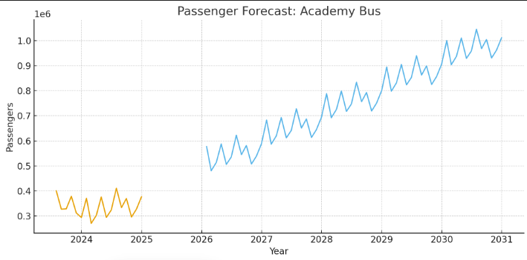
The first forecast plot, representing Academy Bus, shows a stable historical pattern followed by a pronounced upward projection extending through the end of the decade. Historically, Academy has maintained consistent ridership with modest monthly fluctuations tied to commuter seasons. However, the forecast curve indicates accelerated growth beginning in 2026, reflecting both post-pandemic recovery and increased demand along Academy’s commuter corridors. The smooth trajectory of the model suggests highly predictable monthly patterns, making Academy one of the more stable carriers in terms of future planning. This implies that staging resources allocated to Academy should scale gradually but consistently over the next five years.

1.3 Passenger Forecast: Coach USA
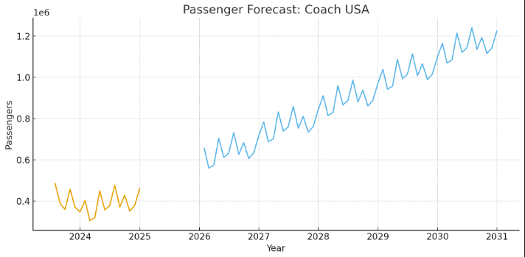
The second plot, covering Coach USA, displays a similar seasonal structure but with visibly larger historical peaks compared to other commuter carriers. Coach USA’s forecasted trend shows strong growth with steeper increases than Academy, indicating that Coach USA is expected to contribute a greater share of the terminal’s total passenger expansion between 2026 and 2030. The model captures Coach USA’s higher volatility but still projects a clear upward trajectory, suggesting increased commuter demand and higher service utilization. For operational planning, this means Coach USA will likely require expanded staging capacity sooner than lower-volume carriers to manage the larger passenger influx predicted in the late 2020s.
1.4 Summary
Across all carriers modeled, the forecasts consistently show rising passenger volumes throughout the 2026–2030 period, with the magnitude of growth varying significantly by carrier. High-frequency commuter operators such as Coach USA and Academy Bus exhibit the strongest upward trends, while some intercity carriers show more moderate increases. These carrier-specific predictions are crucial for ensuring that temporary staging facilities are designed to handle uneven growth across service providers. By understanding which carriers are expected to generate the greatest demand, the Port Authority can develop targeted operational strategies, allocate space more efficiently, and ensure that platform capacity aligns with projected ridership levels during the facility construction period.

